Intersectionality Series – Individual Learning Plan

About the Intersectionality Series
The Intersectionality Series is provided as a SAGE Subscriber benefit and is designed to provide practical support to institutions to enable them to take an ethical, intersectional approach to their gender equity, diversity and inclusion work.

It is delivered online, via Zoom, and alternates input sessions from expert academics, researchers and practitioners, and reflective guided discussion sessions.

The Intersectionality Series is a key part of the SAGE Capacity Building Program in 2022. It is coordinated by SAGE and a cross-institutional Intersectionality Special Interest Group.

Intersectionality Series Aims
The Intersectionality Series aims to:
- develop a shared understanding of what it means to take an intersectional approach to gender equity work, particularly within the context of the SAGE Athena Swan pathway
- promote awareness of the rationale for, and importance of, taking an intersectional approach to gender equity work
- provide practical, evidence-informed guidance to support practitioners in taking an ethical, intersectional approach to understanding, and removing, barriers to gender equity, diversity and inclusion
- share gender research methodologies, good practice, and evidence to support practitioners in their gender equity, diversity and inclusion work

Individual Learning Plan
To support you to engage with the Intersectionality Series, and to derive maximum benefit from it, we invite you to make use of this Individual Learning Plan. It is designed to help you:
- focus your learning goals for each session
- reflect on the information shared in the input sessions
- relate session content to you personally, and to gender equity, diversity and inclusion practice in your institutional context
- identify gaps in your knowledge and skills, and ways you can fill those gaps
- participate actively in the Reflection in Practice sessions

Individual Positionality
Before the first session, it may be useful to reflect on your own positionality.

Positionality refers to how differences in social position and power shape identities and access in society. It is important for researchers “to identify their own degrees of privilege through factors of race, class, educational attainment, income, ability, gender, and citizenship, among others” for the purpose of analysing and acting from one’s social position “in an unjust world.”

You may like to use the diagram below to help you to reflect on the social position that you bring to your work.
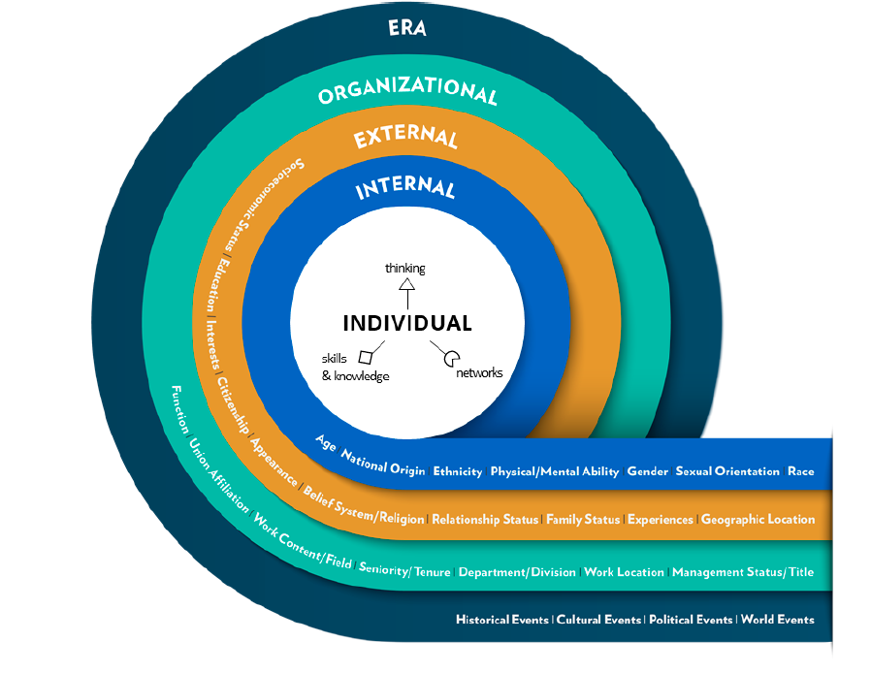

Organisational Positionality
You might also like to reflect on your organisation’s positionality. It can be useful to think about this in terms of power and privilege in the institution.
- What are the values, demographics, and histories of your organisation?
- Which people or groups hold power and/or privilege within your organisation? Are there certain social identities that might be markers of privilege – or, conversely, of marginalisation – within your organisation?
- Where does organisational power or privilege come from? What are the values within your organisation that confers this power and privilege on certain people or groups, and not on others?
- What are the structures and systems through which organisational power and privilege are gained, expressed, and perpetuated?
- What kinds of power and privilege are embedded within your own role within your organisation?
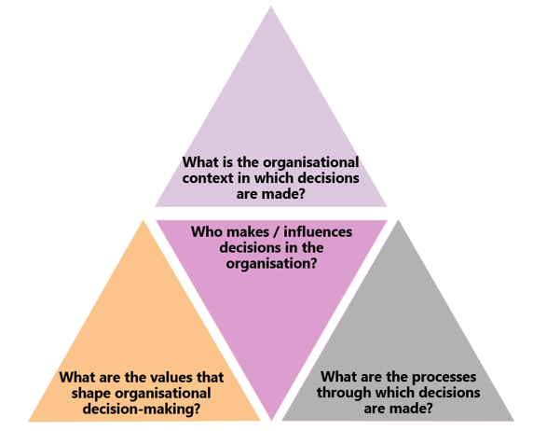

Diagram adapted
from Topp et al (2021)

Individual Learning Plan Template
Please duplicate this template for each Input Session.
Input Session #
Before the Session
Look at the session title and the guiding questions. What do you hope to gain from the session?

After the Session
What did you learn from the session?

How did the session content relate to you personally?

How will you use the session content to inform and support gender equity, diversity and inclusion practice in your institution?

What did you hope to gain from the session but didn’t? How will you seek to fill that gap?

What was unclear or confusing? How will you seek to gain clarity?

What insights will you share with your peers in the Reflection in Practice session?

Duarte, M.E. (2017). Network Sovereignty: Building the Internet Across Indian Country. Seattle: University of Washington Press.
Thomas C, MacMillan C, McKinnon M, Torabi H, Osmond-McLeod M, Swavley E, Armer T and Doyle K (2021) ‘Seeing and overcoming the complexities of intersectionality’, Challenges, 12(1):5.
Topp SM, Schaaf M, Sriram V, Scott K, Dalglish SL, Nelson EM, Rajasulochana SR, Mishra A, Asthana S, Parashar R, Marten R, Quintas Costa JG, Sacks E Rajeev BR, Reyes KAV and Singh S (2021) ‘Power analysis in health policy and systems research: a guide to research conceptualisation’, BMJ Global Health, 6(11).

